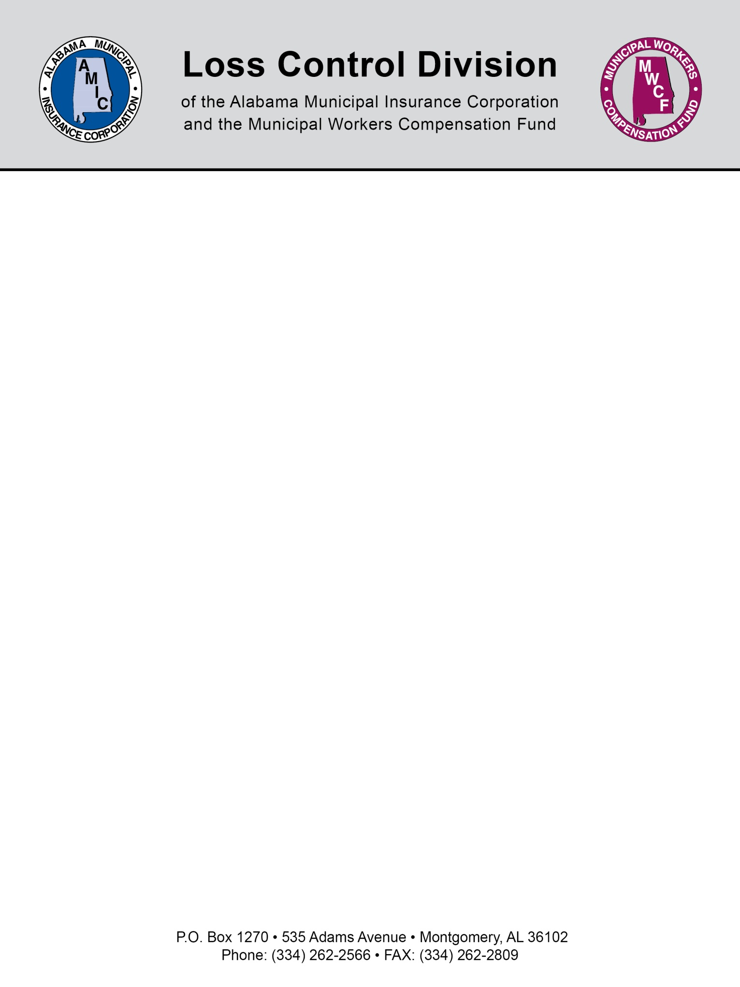

Habitual Worker’s Comp Claimant Counseling Guidelines

We recommend that all employees that file more than two workers’ compensation claims within a twelve month period should be counseled. The counseling sessions should be tailored to meet the claim’s circumstances. For instance, an injury should be addressed in terms of its severity. This process should not be designed in order to find fault, and it is paramount that the claimant be assured of this, but should uncover a chain of causative factors that led to the event of injury. The reasons for counseling have a twofold effect. First and foremost, it should help the employee to see the contributing elements that led to his/her injury. This should help prevent recurrence. Secondly, it heightens the employee’s accountability to his/her supervisors. We also recommend that this policy be added in writing to the Employee Handbook and these counseling sessions be documented.

A few recommended guidelines to consider when developing your own counseling program.

- This process should not be designed in order to find fault, blame or punish the claimant and should be designed in such a way not to seem to the claimant as some form of interrogation. It should be structured as a “what can we do to help you avoid this from happening again”.
- The purpose of the counseling should be to uncover the chain of events that led to the event of injury with a view to prevention.
- The reason for the counseling should be to help the employee to see the contributing elements that led to his/her injury. Again hopefully this will prevent recurrence.
- It should also give the employee an opportunity to make their own suggestions as to steps that need to be taken to help prevent that kind of accident from happening again.
- It could address the issue as to whether some additional equipment or some additional training would have helped prevent to accident.
- It should determine whether there are some current personnel or safety policies that need to be changed, added or rewritten in light of the accident.
- The process will also heighten the employee’s accountability for their own safety and demonstrate that the employer takes its employee’s safety seriously.

NOTE: This document is not intended to be legal advice. It does not identify all the issues surrounding the particular topic. Public agencies are encouraged to review their procedures with an expert or an attorney who is knowledgeable about the topic. Reliance on this information is at the sole risk of the user.

Revised 8/2013

